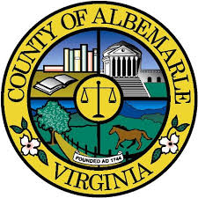
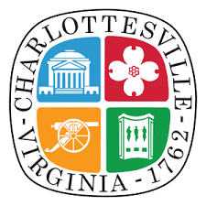
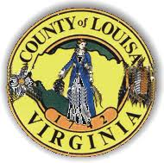
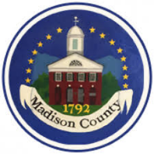
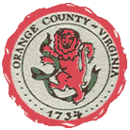
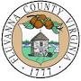
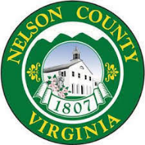
Thomas Jefferson Area Community Criminal Justice Board 2022 Roster

Tommy Barlow, Supervisor, Government Representative, Louisa County Government
Marna Bentley, Region Ten, Community Services Board Representative
Clarissa Berry, Commonwealth's Attorney, Madison County Representative
Ross Carew, Executive Director, Offender Aid and Restoration (OAR)
Avnel A. Coates, Chief Magistrate, 16th Judicial District
Kaki Dimock, Director, Albemarle County Department of Social Services
Honorable Dale Durrer, Judge, General District Court Representative
Marie Durrer, Supervisor, Government Representative, Greene County
Amanda Galloway, Assistant Commonwealth’s Attorney, Fluvanna County Government Representative
Neal S. Goodloe, Jr., Criminal Justice Planner, Staff to the CCJB
Jim Hall, Retired Police Chief, Nelson County Citizen Representative
Col. Martin Kumer, Superintendent, Albemarle-Charlottesville, Regional Jail Representative
William Logan, Citizen Representative, Orange County
Leah Puryear, City Council, City of Charlottesville Government Representative
Lieutenant E. “Tripp” Martin, Albemarle Police Department, Albemarle County Representative
Stephanie McDonald, Chief Probation Officer, Probation & Parole District 26, Member at Large
James Jewett, Supervisor, Madison County Government Representative
Hosea Mitchell, Citizen Representative, Charlottesville
Honorable Richard Moore, Judge, Circuit Court Representative
Brandy Bischoff, Chief Probation Officer, Probation & Parole District 9, Member at Large
Nick Reppucci, Assistant Public Defender, Defense Attorney Representative
Jesse Rutherford, County Supervisor, Nelson County Government Representative
Theodore Voorhees, County Administrator, Orange County Government Representative
David Wells, Director of Public Safety & Chief of Police, Lake Monticello Owners Association, Citizen Representative

